**NCP3106: SOFTWARE DESIGN (LABORATORY)**

1st Semester, School Year 2021 - 2022

**MP2: (HTML + CSS) Student Bio Note**

Machine Problem No. 2

Submitted by:

**LAGUNDA, JAMES B.**

20190157370

Submitted to:

**Engr. ERROL JOHN M. ANTONIO**

Assistant Professor, DCpE

AUGUST 29, 2021

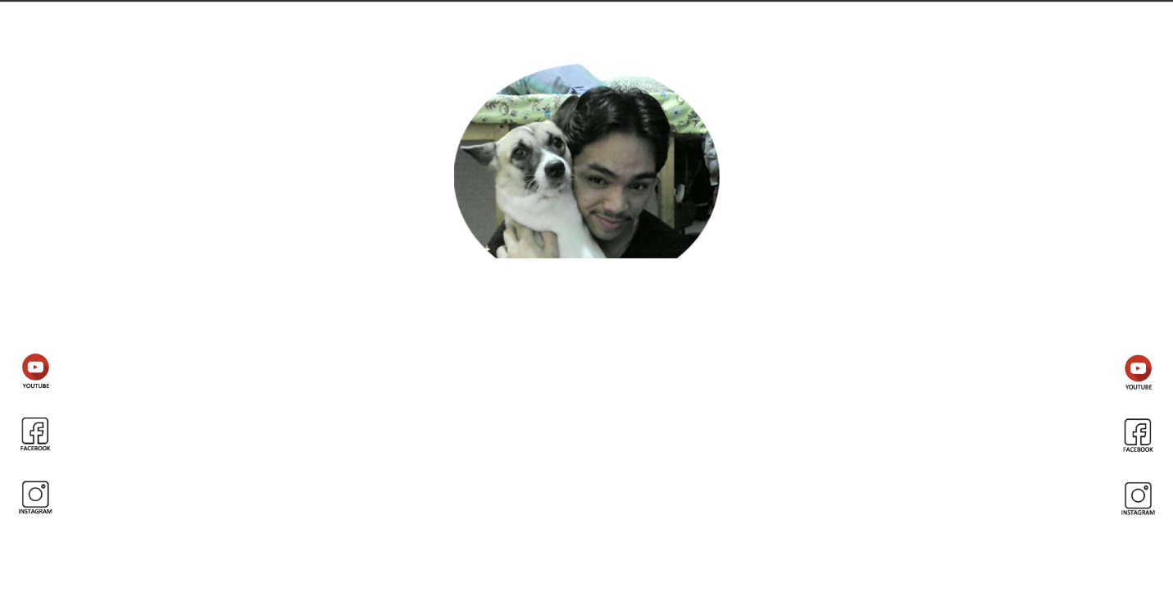

MP1 (HTML ONLY)

